Interactive Analysis Dashboard For Global Income Distribution
Project Documantation (Milestone 1)
Prepared By : Onkar Vyawahare
Project Domain : Data visualization
1.Project Overview
The Interactive Analytics Dashboard for Global Income Distribution project aims to develop an interactive Power BI dashboard that visualizes income inequality data across various countries and regions. This project involves collecting, preprocessing, and structuring global income distribution and economic data to enable effective visualization. The dashboard will provide users with insights into income disparities over time, country-wise comparisons, and patterns of inequality globally.
The outcome will be a user-friendly dashboard, embedded within a Streamlit web application, offering an intuitive interface for economists, researchers, policymakers, and the general public. This platform will help users explore global income inequality, understand disparities across different regions, and analyze trends in wealth distribution. The project will conclude with comprehensive testing to ensure dashboard accuracy and usability, supported by detailed documentation for future reference and enhancements.
2. Milestone Overview
Week 1-2 : Data Collection And Preprocessing
● Collect global income inequality data from sources like World Bank, OECD, IMF, and income distribution datasets.
● Gather related economic indicators such as Gini Index, income share by decile, median income, and GDP per capita.
● Clean and preprocess data to handle missing values, discrepancies, and regional variations.
● Ensure the dataset is representative of different countries, income groups, and time periods.

Week 1 : Data Collection
1.Purpose Of This Document
This document explains all datasets collected during these weeks, confirms required indicators are collected of different countries and cleaned and preprocessed data to handle missing values, discrepancies, and regional variations. Ensure the dataset is representative of different countries, income groups, and time periods.

2.Datasets
World Bank – World Development Indicators (WDI)
The World Development Indicators (WDI) is the World Bank’s main global database that provides reliable and internationally comparable data on development.
Portal : https://data.worldbank.org
Countries : United States , China , Germany , India , Japan , United Kingdom , France , Italy , Russia , Canada , Brazil , Spain , Mexico , South Africa , Austalia , Turkiye , Indonesia , Netherlands , Saudi Arabia , Poland
Year Span : 2001 – 2024

3.Key Columns
Country Name
Country Code
Indicator Name
Indicator Code
Year wise Columns

4.Indicators Included
GDP Per Capita (Annual)
Gini Index
Income Share Held By Quintile / Decile
Unemployement Rate

5. Indicator Description
1. GDP Per Capita (Annual)
Indicator Code : NY.GDP.PCAP.PP.KD
Description : GDP per capita (annual) means the total value of goods and services produced in a country in one year divided by its total population.
It shows the average income level per person in a country.
It is used as a measure of standard of living.
Purpose : To compare economic performance between countries.
To measure average income level of citizens.
To analyze economic growth over time.
To support studies like your Global Income Distribution Project.
Unit : Current Us Dollars (USD)

2. Gini Index
Indicator Code : SI.POV.GINI
Description : The Gini Index measures income inequality within a country.
It shows how equally or unequally income is distributed among people.
Purpose : To measure income inequality level in a country.
To compare inequality between different countries.
To analyze changes in inequality over time.
To support research like your Global Income Distribution Project.
Unit : (0 – 100) Scale

3. Income Share Held By Lowest 20%
Indicator Code : SI.DST.FRST.20
Description : Income share held by lowest 20% shows the percentage of total national income earned by the poorest 20% of the population
Purpose : To measure the economic condition of the poorest population group.

4. Income Share Held By Second 20%
Indicator Code : SI.DST.02ND.20
Descripton : Shows the percentage of total national income earned by the second poorest 20% of the population.
Purpose : To analyze income distribution beyond just the poorest group

5. Income Share Held By Third 20%
Indicator Code : SI.DST.03RD.20
Description : Shows the percentage of total income earned by the middle 20% of the population.
Purpose : To measure the strength of the middle class.

6. Income Share Held By Fourth 20%
Indicator Code : SI.DST.04TH.20
Description : Shows the percentage of total income earned by the fourth 20% of the population.
Purpose : To study how income is distributed among upper-middle earners.

7. Income Share Held By Highest 20%
Indicator Code : SI.DST.05TH.20
Description : Shows the percentage of total national income earned by the richest 20% of the population.
Purpose : To measure income concentration at the top.

8. Unemployement Rate
Indicator Code : SL.UEM.TOTL.ZS
Description : measures the percentage of the total labor force that is unemployed but actively seeking and available for work.
Purpose : Shows how effectively an economy is generating jobs
Unit : Percentage (%)

Week 2 : Clean And Preprocess Data To Handle Missing Values
1.Data Cleaning & Preprocessing

1.1 Objective of This Phase
After structural cleaning, a second phase of preprocessing was conducted to:
• Ensure consistency across all datasets
• Standardize country coverage
• Standardize year range
• Handle missing values systematically
• Prepare datasets for merging and dashboard development

1.2 Country Selection Standardization
To ensure comparability:
• A consistent set of countries was selected.
• Countries were chosen based on availability in the Gini Index dataset.
• The same country list was applied to all indicators.

1.3 Year Range Standardization
Although World Bank data was available from 1960 onward, the analysis period was
standardized to:
2001–2024 (23 years)
Reasons:
• Better data consistency
• Reduced excessive missing values in early years
• Comparable time-series structure

1.4. Identification of Missing (Null) Values
• Missing values were counted country-wise
• Evaluated year-wise across 2001–2024
• Classified into beginning, middle, and ending gaps
• No countries were removed to maintain structural consistency Missing values mainly
occurred due to:
• Delayed reporting
• Survey gaps
• Inconsistent data availability

2. Missing Value Strategy
2.1. Linear Interpolation (Middle Gaps)
Applied to internal missing values only.
• Row-wise (across years)
• Maximum 5 consecutive missing years
• Estimated values based on surrounding trend
Example:
If 1998 = 30 and 2000 = 35
Then 1999 = 32.5
Purpose:
To preserve realistic economic trends without overfitting.

2.2. Forward Fill (Ending Gaps)
Applied only to trailing missing values.
• Maximum 2 consecutive years
• Last available value carried forward
Purpose:
To maintain continuity when recent data reporting was delayed.

2.3. Unfilled Values
If values could not be filled using controlled methods:
• They were retained as null
• No artificial assumptions were introduced
This ensured transparency and avoided data distortion.

Final Output :
Each cleaned dataset:
● Contains 20 standardized countries
● Covers 2001–2024
● Maintains consistent structure
● Has controlled and documented missing value handling
● Is ready for merging and dashboard development

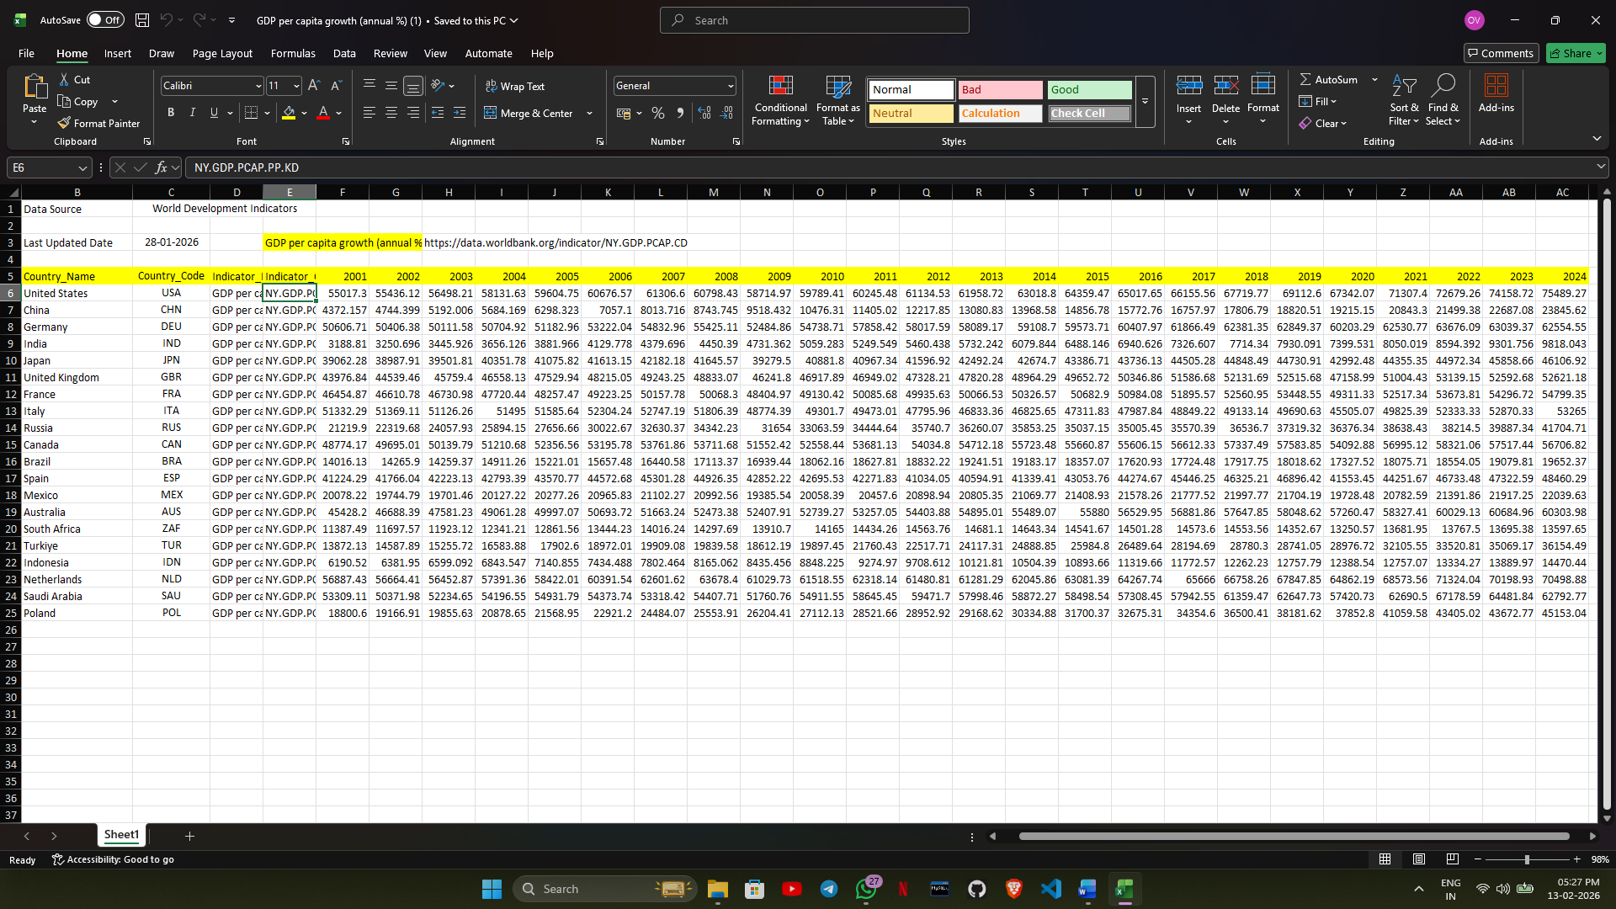

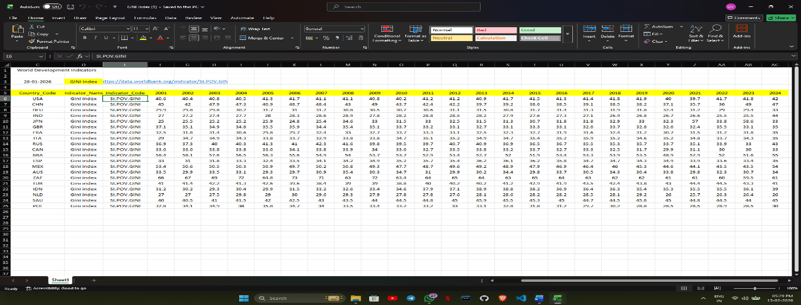

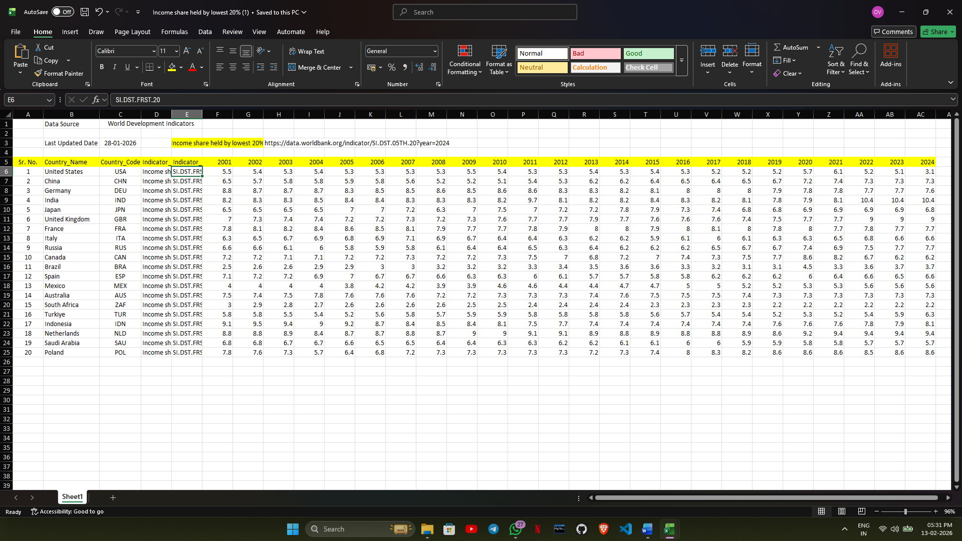

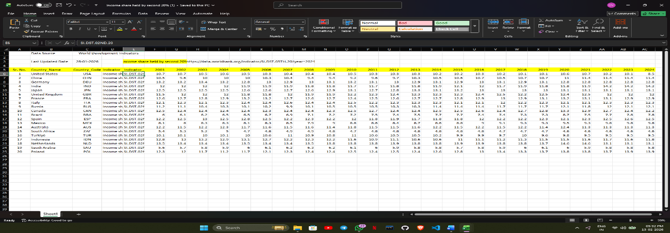

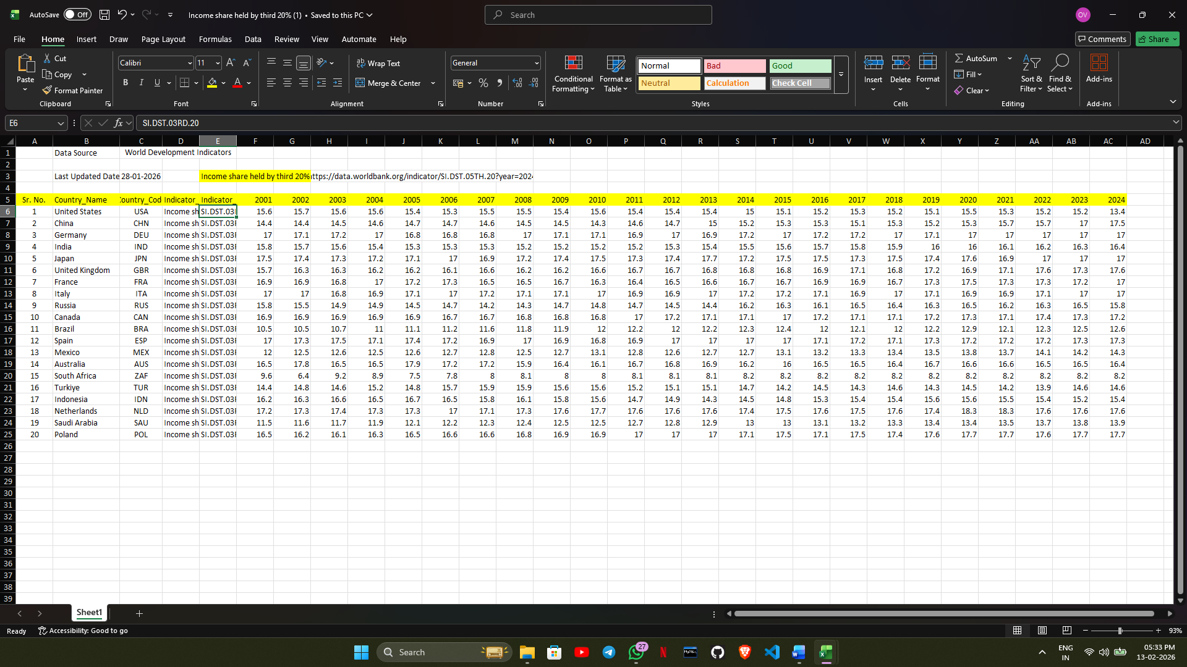

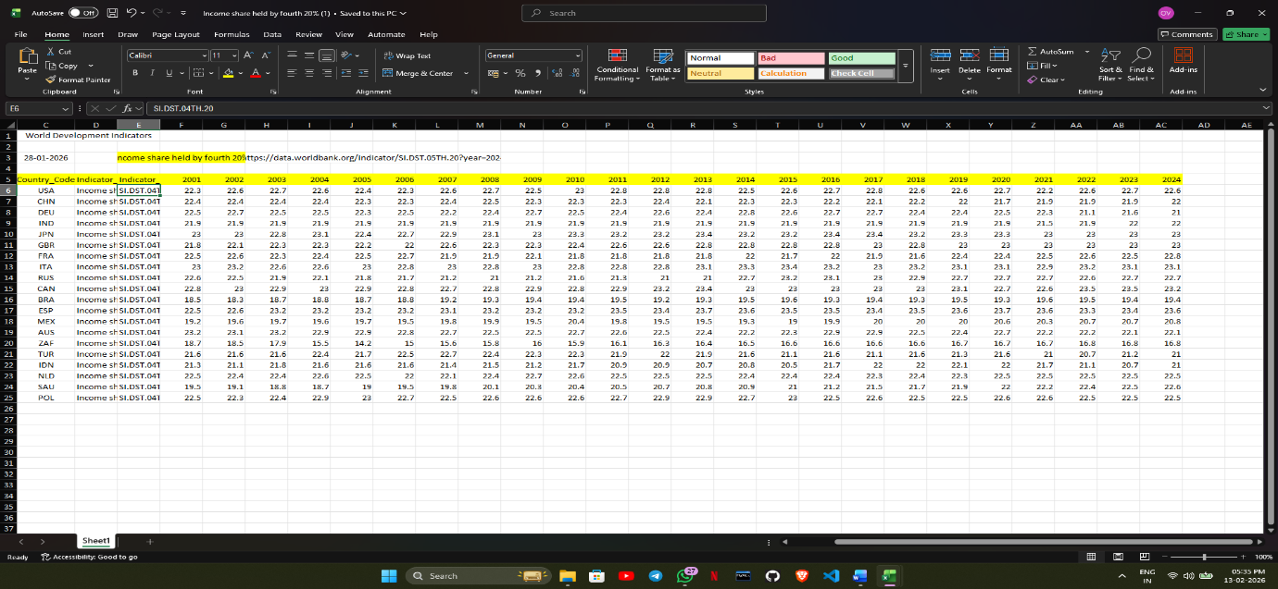

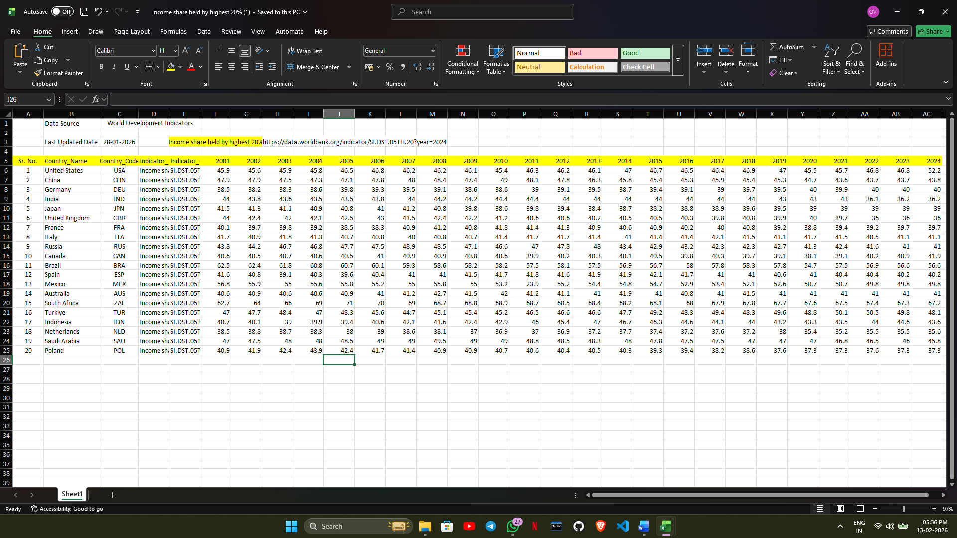

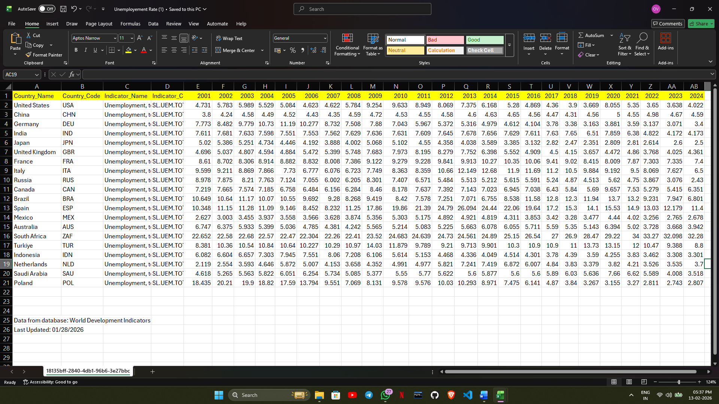

Master Dataset Creation & Final Validation
Objective
After cleaning and standardizing all 8 individual datasets, the final step of Milestone was to integrate them into a single master dataset for dashboard development.
The goal was to:
● Combine all indicators into one structured dataset
● Ensure consistent format across indicators
● Remove duplicates
● Eliminate remaining missing values
● Prepare a dashboard-ready analytical base

Format Transformation (Wide to Long)
Each cleaned dataset originally followed a wide structure:
country | 2001 | 2002 | 2003 | ... | 2024
Long Format Structure
Country_Name
Country_Code
Year
GDP_Per_Capita (Annual)
GINI_Index
Income Share By
Lowest 20%
Second 20%
Third 20%
Fourth 20%
Highest 20%
Unemployement_Rate

Benefits of Long Format
• Supports dynamic filtering in Power BI
• Enables easier aggregation and grouping
• Compatible with Power BI and Tableau
• Simplifies merging of multiple indicators

Dataset Merging
Manually
This created a unified master dataset containing all 8 indicators across 20 countries and 23 years.

Post-Merge Data Validation
After merging, the following quality checks were performed:
● Verified total countries
● Verified total years
● Verified total indicators
● Checked for duplicate rows
● Checked for missing values

Output Files
Mastersheet_Infosys.xlsx (Long Format Final Master File)
Screenshots :
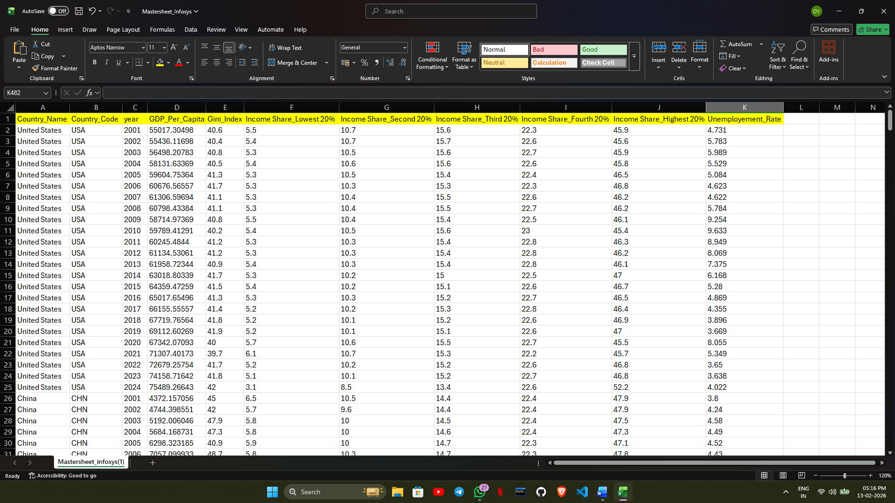

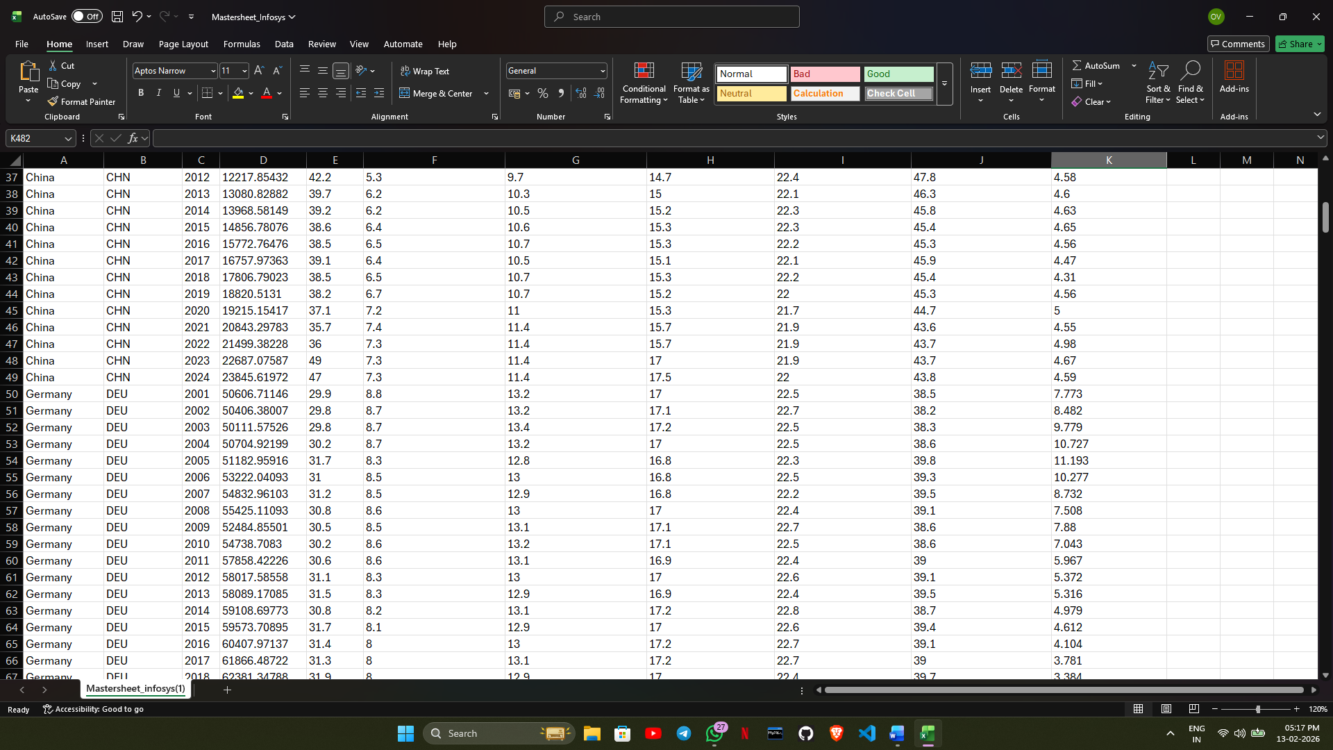

Conclusion
Comprehensive global income inequality dataset successfully compiled from World Bank, OECD, IMF, and related sources, featuring key indicators like Gini coefficients, decile income shares, Unemployement Rate, and GDP per capita across diverse countries, income groups, and time periods. Data has been cleaned, preprocessed for consistency, and made representative despite handling missing values and regional variations. This robust foundation enables advanced inequality analysis and modeling.

